**Lab - Creating a Virtual Install of Windows 10 Pro Using VirtualBox**

**Overview**

This lab will allow users to create a Windows 10 host to be used for testing their Server 2012, 2016 or 2019 network. This VM can be used for testing file and printing access, IIS and FTP and other 2012, 2016 or 2019 Microsoft roles and services.

**If you experience slowness and sluggish issues with your VM’s try the following:**

1. Try freeing up your resources by disabling your security suite on the host and not using the machine while your VM’s are running.

2. If you have 4 GB of RAM on the host, you can allocate 2 GB for the VM’s. The RAM is only being utilized when the VM’s are up and running.

3. Use the defragmentation utility built into VirtualBox under storage in the VM’s settings. This usually improves performance.

4. Be sure to shut down your VMs as you would your host machine using the start button and then shut down. Do not just power off you’re your VirtualBox Player with the VM running! This is no different than pulling the power cable out of the wall used to power your host machine.

**Overview**

**Download the Windows 10 ISO Image**

The HeiDoc.net **Microsoft Windows and Office ISO Download Tool** allows an easy and comfortable way to download genuine Windows 8.1 and Windows 10 disk images (ISO) directly from Microsoft's servers, as well as Office 2013, Office 2016, and Office for Mac.

In the past, Microsoft provided disk images for many of their products through their subcontractor "Digital River". These downloads were pulled in early 2014. Afterwards, Microsoft made a limited selection of downloads available on their TechBench site. This tool accesses that TechBench site and unlocks many hidden download files on it.

Download Microsoft Windows and Office ISO Download Tool [here](https://www.heidoc.net/joomla/technology-science/microsoft/67-microsoft-windows-and-office-iso-download-tool).

The ISO downloader tool is a self-running executable and does not need to be installed. Once you have the tool downloaded, just x2 click it to open.

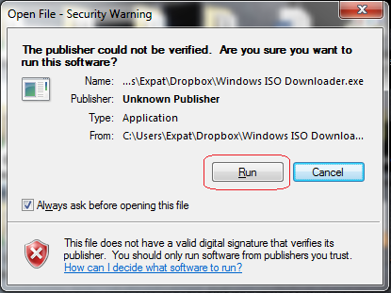

Use the following set of images to help guide your download.

On the About page choose Windows 8.1 or Windows 10 as your download. (Windows 7 ) does not work.

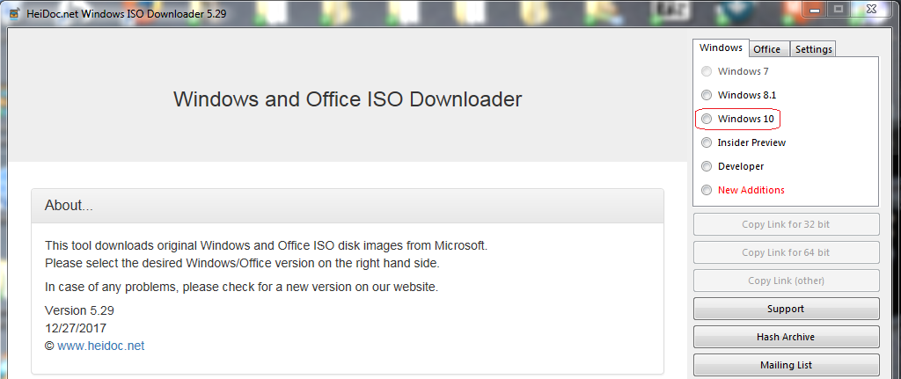

On the next page, select your edition.

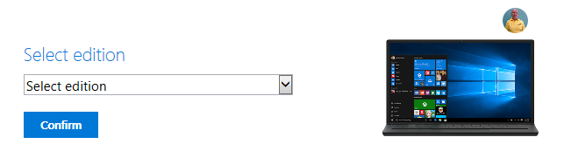

From the very top, choose the Windows 10 Home/Pro edition.

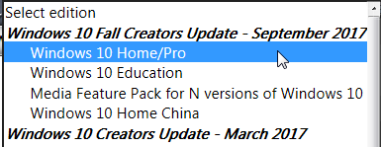

Confirm

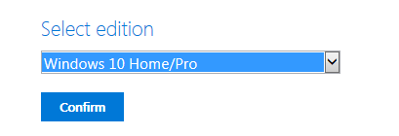

Select a product language and confirm.

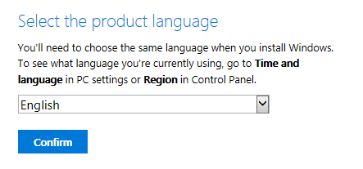

Select your version based on your hardware type.

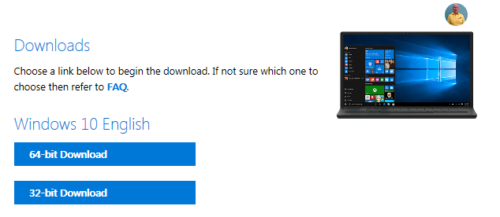

Your download begins. Save it to a location preferably away from your C:\ drive.

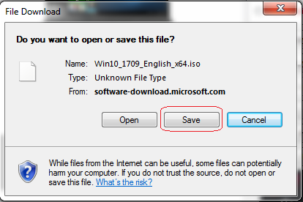

Save the ISO to a location where you can easily retrieve it. I recommend saving all your ISO images a separate partition, an external drive or using a free online storage solution such as Google Drive or DropBox.

In this example, I am saving the Windows 10 ISO download to the cloud using my Dropbox account where I have folder called ISO images.

**Creating a Virtual Install of Windows 10**

Open VirtualBox.

From the taskbar, click on the New button to open the Create a Virtual Machine Wizard.

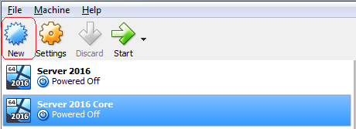

The Create a Virtual Machine Wizard opens. Give your new virtual machine a user friendly name.

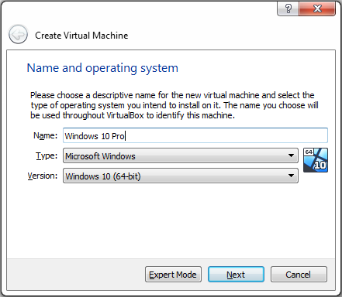

Accept the default size for the RAM.

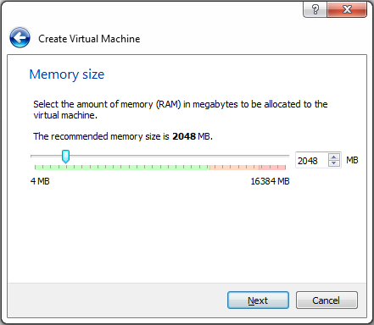

Accept the default to, Create a Virtual Hard Disk Now. Click on Create.

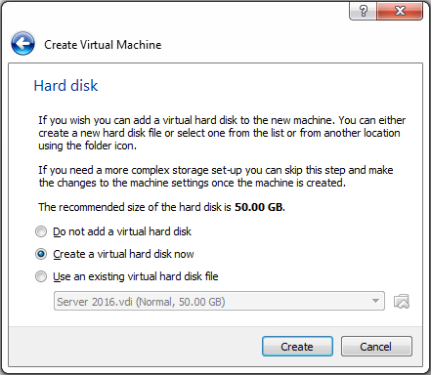

On the next screen, accept the default for using the VDI disk file type.

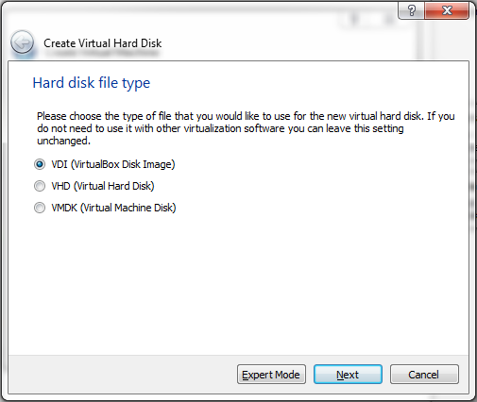

Accept the default to use a dynamic storage disk.

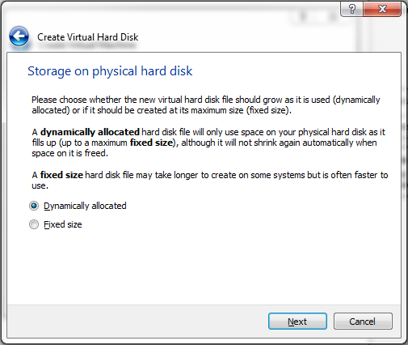

On the next screen, accept the default disk size of 50 GB. Click Create.

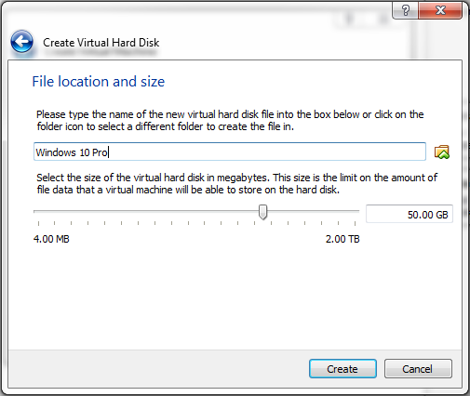

Back at the VirtualBox management console from the left Window pane, find your newly created Windows 10 machine, highlight and from the taskbar, click the great start arrow.

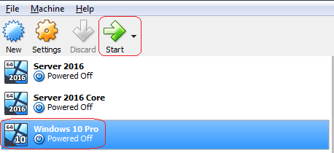

On the next windows

1. Browse to the location of Windows 10 ISO image.

2. Select the image.

3. Press the start button.

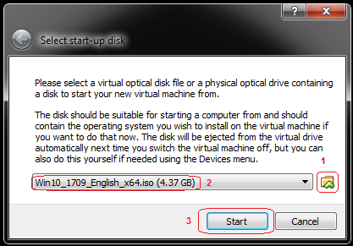

The Windows 10 installation starts. Click next.

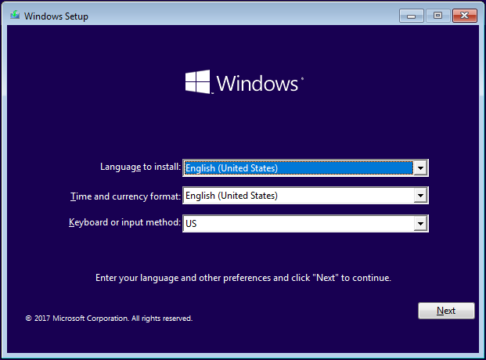

On the next windows, click on the Install now button.

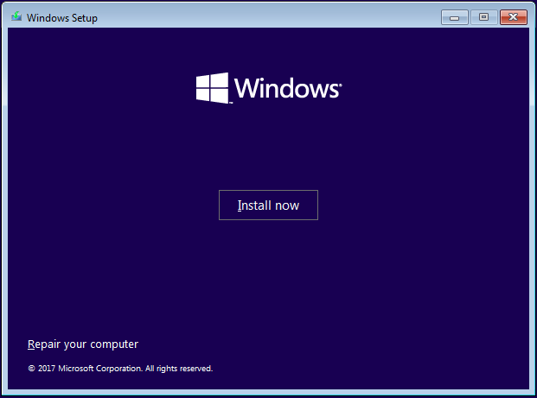

On the Activate Windows screen, you can click the link entitled, I do not have a product key.

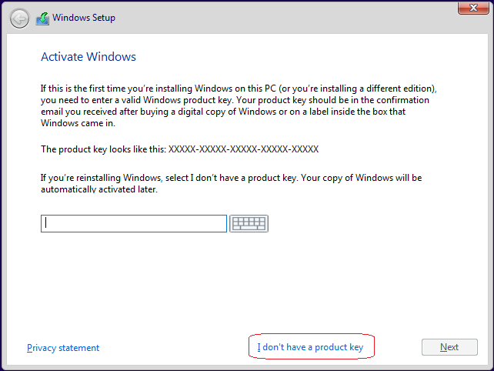

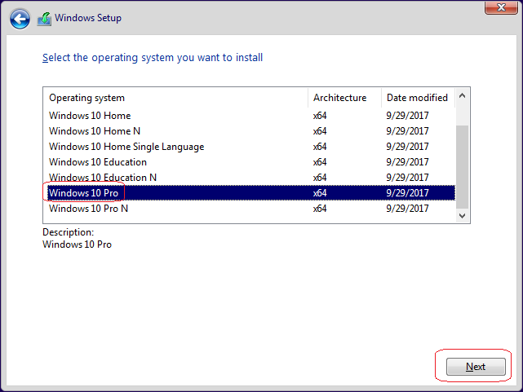

On the license screen, check the to accept the terms. Click Next.

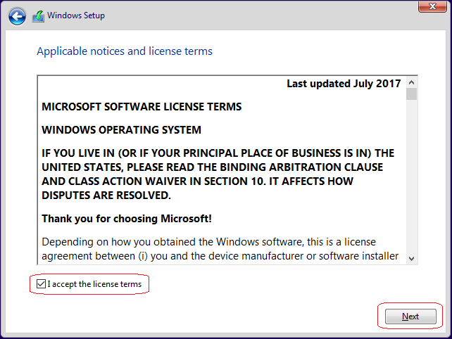

On the next screen click on the option marked Custom.

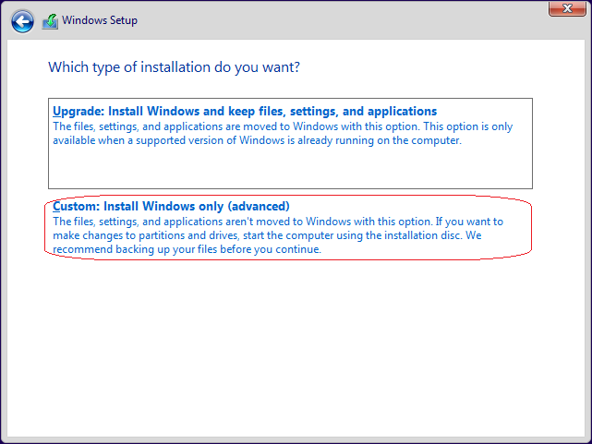

On the next Window, you only need to click on the Next button.

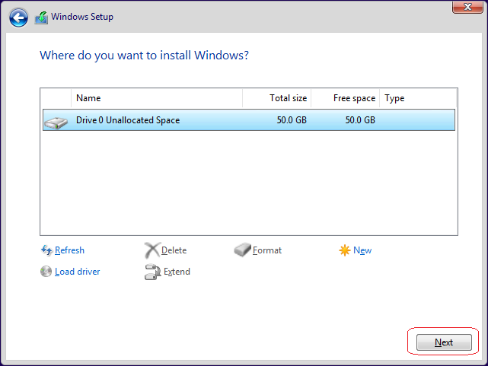

The installation begins.

Allow the install to proceed without any interruption.

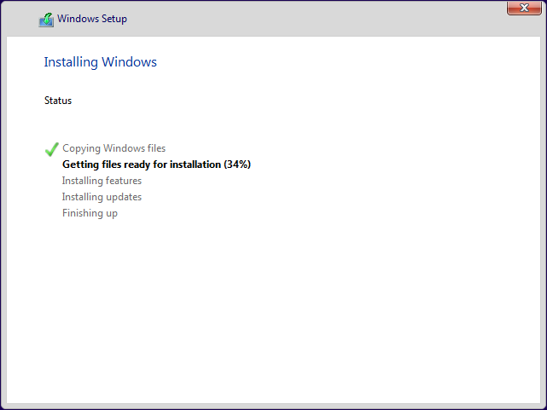

This step will take some time so relax, go for a walk, watch some TV but allow the install to complete. The Easy Install feature of VMWare will do all the work.

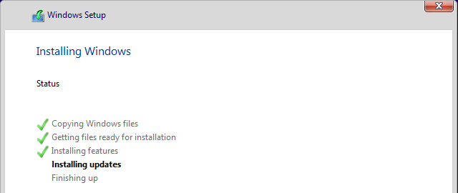

Windows will restart …..

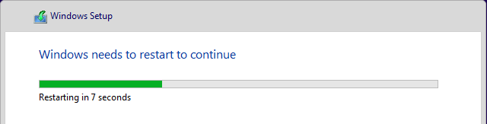

Windows will prepare for your first use and prepare your desktop.

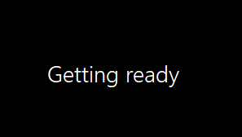

Windows will restart one more time…. wait for the desktop or login.

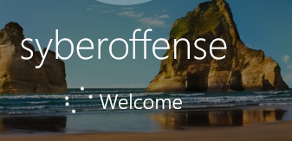

Windows 10 continues with the building of the user’s profile.



Windows 10 will restart one more time

The Windows 10 Interactive menu begins.

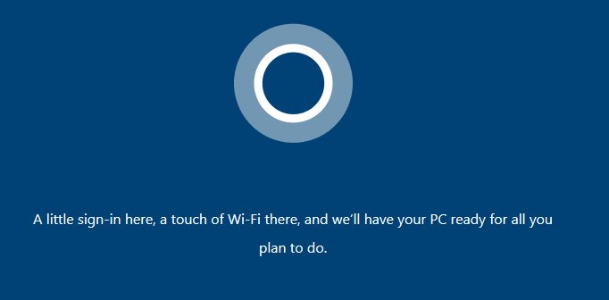

Set your region and click yes.

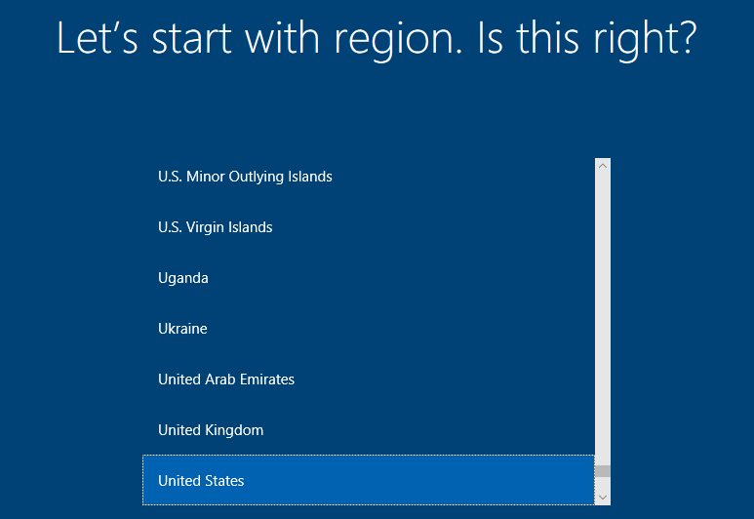

Select your keyboard layout and click yes.

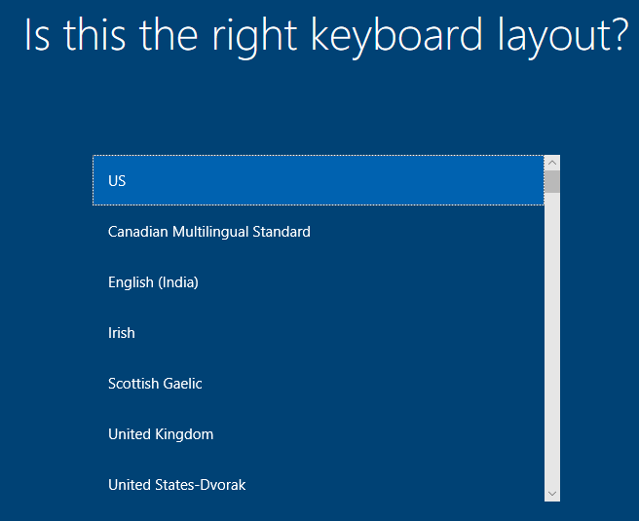

Want to add second keyboard? Click skip.



You can connect to a network or select skip for now. Select, Skip for now.



Select your username and then click next.

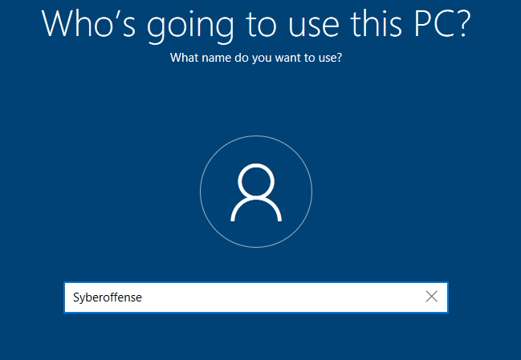

Type in a password. Click Next.

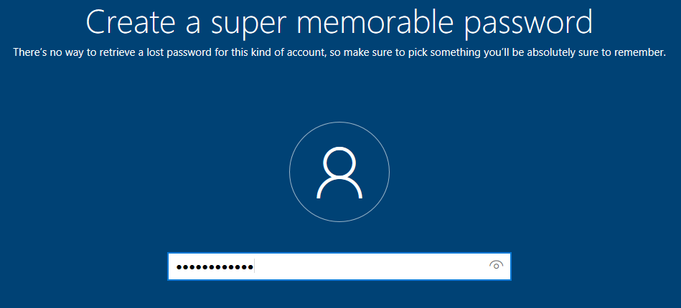

Confirm your password.

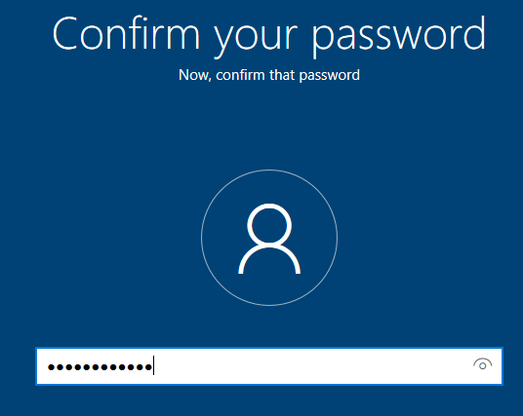

Add a hint for your password. Click next.

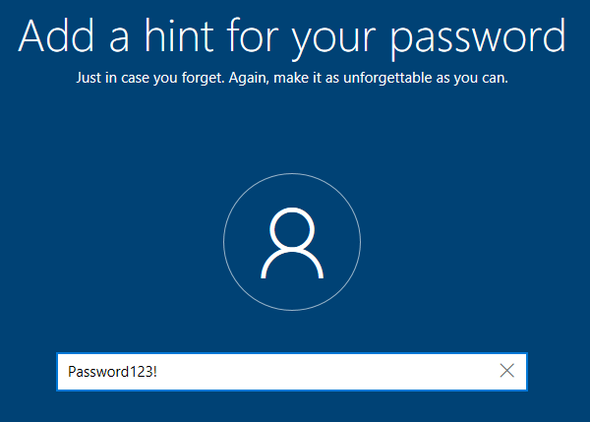

Disable Cortana…or not.

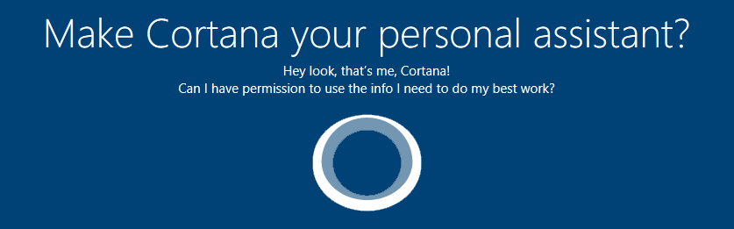

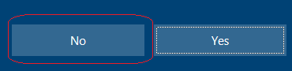

Select your privacy settings. Click accept.

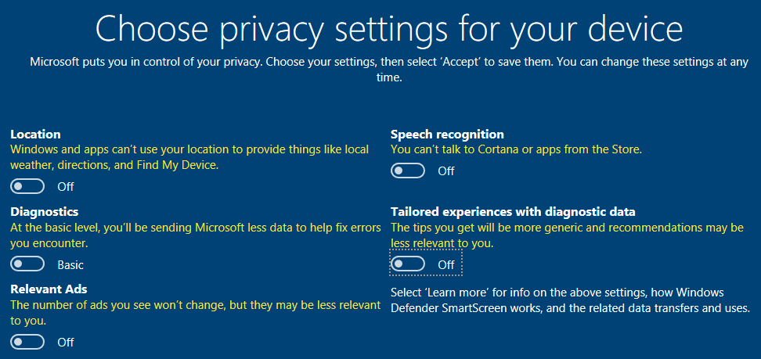

At last!



Once the desktop appears, you may be asked if you want Windows 10 to be discoverable by other devices. I always choose no but you free to select yes.

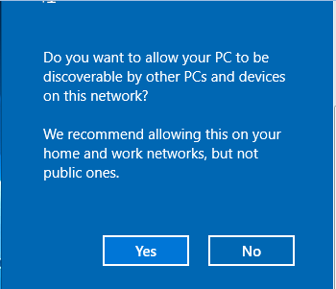

Your Windows 10 client is ready for prime time. In Section 3, we will optimize and add your Windows 10 client to your new Server 2012 or 2016 domain.

**End of the lab!**